**MBS4521 Industrial Automation**

**Assessment: Case Study (30%)**

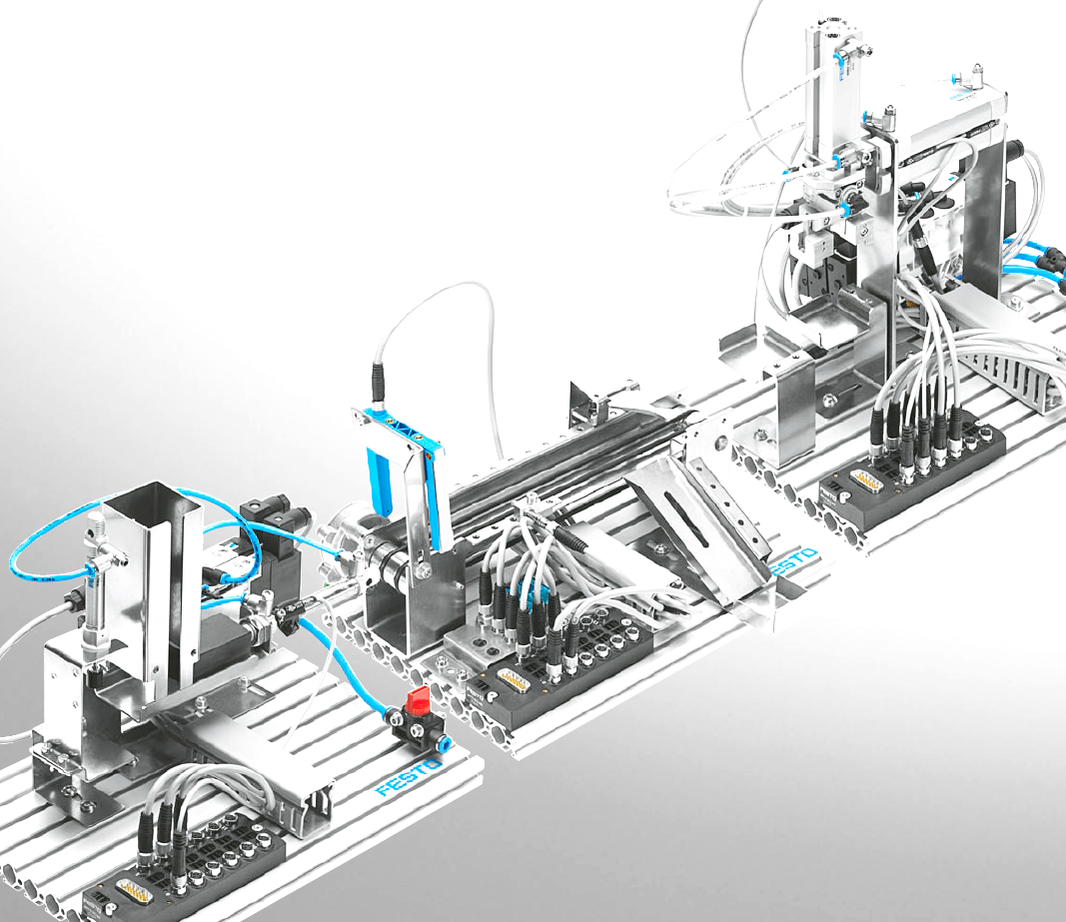

In the given production line system, there are three sub-stations, namely **Stacking Magazine Station**, **Conveyor Station**, and **Handling Station**. Each station handles specific tasks with various input and output components.

In this Case Study, each group will take turn to familiarize each station by testing the full function of each. Then, according to below guideline, design a PLC ladder (for model: NAIS FP∑) for each station.

Follow the guideline and complete the requirement. A typed report in PDF format should be submitted no later than **12 May 2023**.

**Station 1 - stacking magazine station**

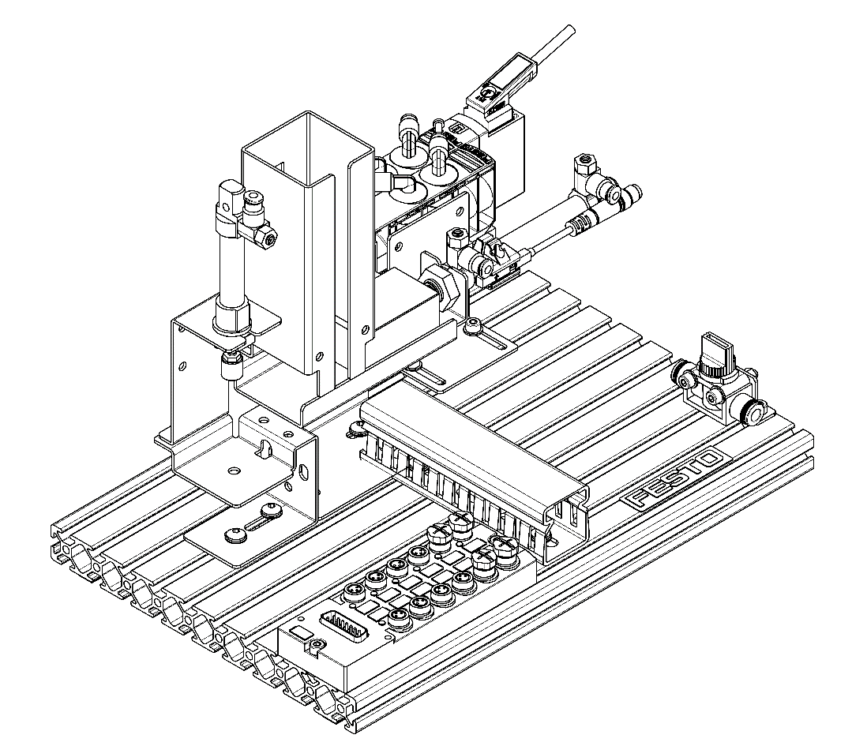

1-1 List out the most important components of the **stacking magazine station** together with their circuit symbol:

|  |  |  |  |  |  |  |
| --- | --- | --- | --- | --- | --- | --- |
| **Item** | **Illustration** | **Part name** | **Part number** | **Symbol** | **Description** | **Qty** |
| ***Example*** |  | **Proximity sensors SME-8M** | **543862** |  | **Magnetic proximity sensor for detecting the**  **position of the cylinder piston** | **1** |
| 1 |  |  |  |  |  |  |
| 2 |  |  |  |  |  |  |
| 3 |  |  |  |  |  |  |
|  |  |  |  |  |  |  |

1-2 Briefly describe the operating sequence of this station.

1-3 Draw the assignment table for this station.

|  |  |  |  |  |
| --- | --- | --- | --- | --- |
| **Component** | **Multi-pin plug distributor - input** | **Multi-pin plug distributor - output** | **PLC input** | **PLC output** |
| ***Example:***  ***Pushbutton (NO)*** |  |  | X0 |  |
| ***Example:***  ***Proximity sensor – magnetic (NO)*** | 1S1 |  | X1 |  |
| ***Example:***  ***Double acting cylinder 1A*** |  | 1M1  1M2 |  | Y1  Y2 |
|  |  |  |  |  |
|  |  |  |  |  |

1-4 Draw the wiring diagram of the station to a PLC (NAIS FP∑) via a distributor.

NOTE: Assume PLC has 16 Inputs (X0 - XF) / 16 Outputs (Y0 - YF)

X0

X1

X2

X3

Y0

Y1

Y3

Y2

1

3

5

7

2

4

8

6

1S1

1S2

1S3

1S4

1M1

1M2

1M4

1M3

10

1M5

12

1M6

9

11

1S5

1S6

X4

X5

Y4

Y5

Magnetic sensor

COM

COM

24V

+24V

**PLC**

**Distributor**

NOTE:

For your reference only. This wiring diagram is not completed!

1-5 Draw the timing diagram of this station.

***Example***:

***magnetic sensor – X1 (NO)***

**X0 (NO)**

**Cylinder 1A**

|  |  |  |  |  |
| --- | --- | --- | --- | --- |
|  |  |  |  |  |
|  |  |  |  |  |
|  |  |  |  |  |

1-6 Design a PLC ladder for the operation.

1-7 Suggest any design improvement for this station.

**Station 2 - Conveyor station**

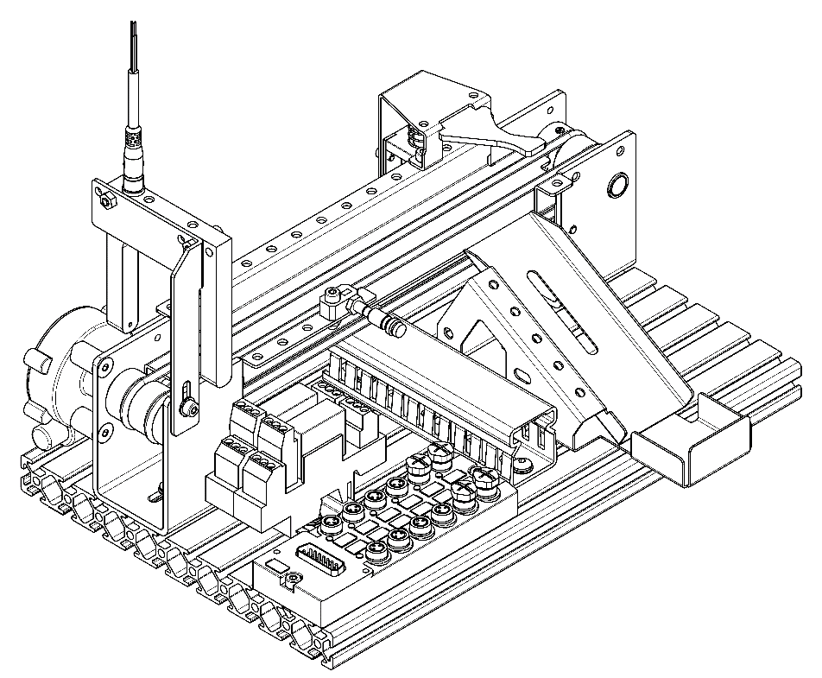

2-1 List out the most important components of the **conveyor station** together with

their circuit symbol:

|  |  |  |  |  |  |  |
| --- | --- | --- | --- | --- | --- | --- |
| **Item** | **Illustration** | **Part name** | **Part number** | **Symbol** | **Description** | **Qty** |
| **Example** |  | **DC geared motor** | **374134** |  | 24 V D.C. gearmotor, moves the belts of the  conveyor and all the workpieces lying on  them. Can run forwards and backwards. | **1** |
| 1 |  |  |  |  |  |  |
| 2 |  |  |  |  |  |  |
|  |  |  |  |  |  |  |

2-2 Briefly describe the operating sequence of this station.

2-3 Draw the assignment table for this station.

|  |  |  |  |  |
| --- | --- | --- | --- | --- |
| **Component** | **Multi-pin plug distributor - input** | **Multi-pin plug distributor - output** | **PLC input** | **PLC output** |
| ***Example:***  ***Optical sensor (NO)*** | 2S1 |  | X2 |  |
| ***Example:***  ***Solenoid K1*** |  | 2M1 |  | Y3 |
| ***Example:***  ***Relay coil K2*** |  | 2M2 |  | Y4 |
|  |  |  |  |  |

2-4 Draw the wiring diagram of the station to a PLC (NAIS FP∑) via a distributor.

X0

X1

X2

X3

Y0

Y1

Y3

Y2

1

3

5

7

2

4

8

6

2S1

2S2

2S3

2S4

2M1

2M2

2M4

2M3

10

2M5

12

2M6

9

11

2S5

2S6

X4

X5

Y4

Y5

optical sensor

COM

COM

24V

+24V

**PLC**

**Distributor**

2-5 Draw the timing diagram of this station.

2-6 Design a PLC ladder for the operation.

2-7 Suggest any design improvement for this station.

**Station 3 - Handling station**

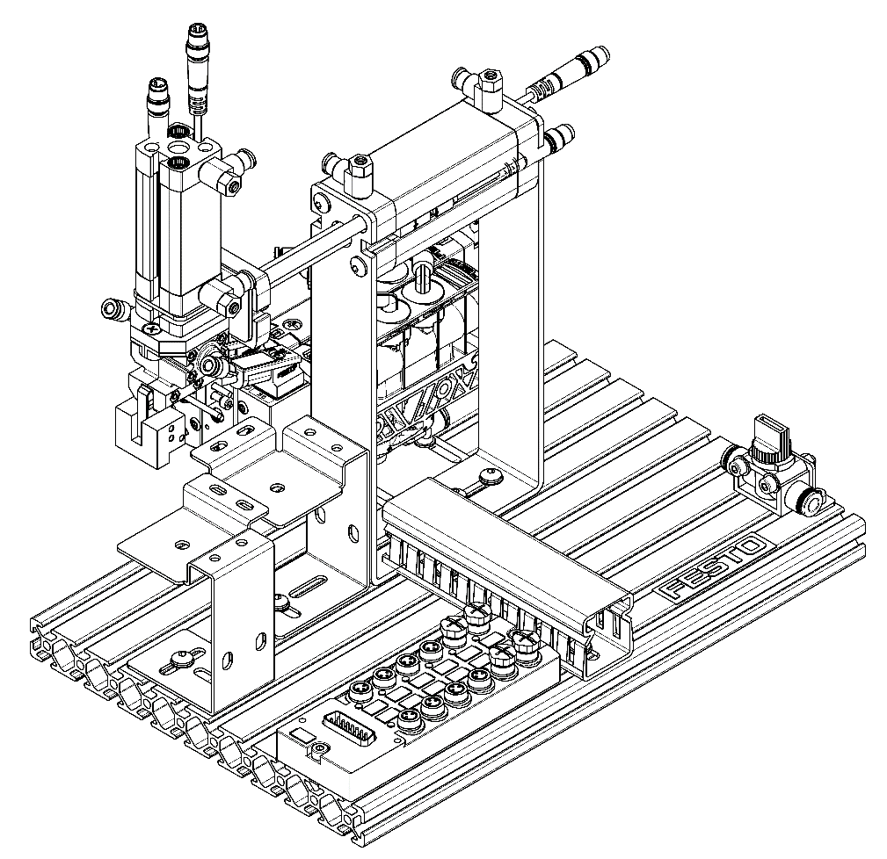

3-1 List out the most important components of the **handling station** together with

their circuit symbol:

|  |  |  |  |  |  |  |
| --- | --- | --- | --- | --- | --- | --- |
| **Item** | **Illustration** | **Part name** | **Part number** | **Symbol** | **Description** | **Qty** |
| 1 |  |  |  |  |  |  |
| 2 |  |  |  |  |  |  |
| 3 |  |  |  |  |  |  |
|  |  |  |  |  |  |  |

3-2 Briefly describe the operating sequence of this station.

3-3 Draw the assignment table for this station.

|  |  |  |  |  |
| --- | --- | --- | --- | --- |
| **Component** | **Multi-pin plug distributor - input** | **Multi-pin plug distributor - output** | **PLC input** | **PLC output** |
| ***Example:***  ***Proximity sensor – magnetic (NO)*** | 3S1 |  | X3 |  |
| ***Example:***  ***Double acting cylinder 2A*** |  | 3M1  3M2 |  | Y6  Y7 |
|  |  |  |  |  |
|  |  |  |  |  |

3-4 Draw the wiring diagram of the station to a PLC (NAIS FP∑) via a distributor.

3-5 Draw the timing diagram of this station.

3-6 Design a PLC ladder for the operation.

3-7 Suggest any design improvement for this station.

|  |
| --- |
| **After completion of the above requirement, in your group report, label the specific section/part that your group member has the most contribution to it!**  **Example:**  2-1 Component list of the **conveyor station** [**by CHAN Tai Man**] |

**Appendix I**

**IVE (Lee Wai Lee) - Department of Engineering**

Higher Diploma in Artificial Intelligence and Robotics

EG114728/1

MBS4521 Industrial Automation

Case Study Report

**< Production Line Automation >**

|  |  |
| --- | --- |
| Group ______ | |
| Student Name | Student Number |
|  |  |
|  |  |
|  |  |
|  |  |
|  |  |
|  |  |
|  |  |
|  |  |

“*We declare that this report is our own work and was not copied from or written in collaboration with any other person”*

|  |  |  |
| --- | --- | --- |
| Student Name | Student Number | Signed |
|  |  |  |
|  |  |  |
|  |  |  |
|  |  |  |
|  |  |  |
|  |  |  |
|  |  |  |
|  |  |  |

*Date:*

**Content**

* + - 1. Introduction
      2. Station 1 –
         1. Component list
         2. Operation sequence description
         3. Assignment
         4. Wiring diagram
         5. Timing diagram
         6. PLC ladder
         7. Improvement
      3. Station 2 -
      4. Station 3 -
      5. Conclusion

|  |
| --- |
| **In your group report, label the specific section/part that your group member has the most contribution to it!**  **Example:**  2(i) Component list of the **conveyor station** [**by CHAN Tai Man**]  :  :  :  :  5 Conclusion [**by CHAN Yee Man**]  ……………. |

**Appendix II**

**Report Format and Specifications**

A neat and consistent style should be adopted throughout the report, and the following format is recommended.

|  |  |  |
| --- | --- | --- |
|  | Font | Times New Roman (12-pt for main text; 7-12-pt for table, charts, etc.) |
|  | Line Spacing | 1.5 lines |
|  | Indexing | Numeric System  1.0 Heading  1.1 Sub-Heading  1.1.1 Paragraph  Xxxx xxx xxx   1. xxxx 2. xxx    1. xxx    2. …   1.1.2 Paragraph  ….. |
|  | Referencing | The program Team should select either IEEE Style or Harvard System for adoption by the students throughout the program.  IEEE Style [1]   * In-text references are numbered in the order of appearance in the report, e.g. Crowford [2] suggests that … and the following equations can be derived by the Chan’s method [3] … * A reference list is displayed at the end of the report according to the numeric order as follows:   [1] *IEEE Editorial Style Manual*, IEEE Periodicals Transactions /Journals Department, 2016, pp.34-42. Available at: [www.ieee.org](http://www.ieee.org) [accessed on 5 Sept 2016]  [2] B. Crowford, Title of Paper, *Name of Journal*, vol x, no. x, pp xx, Month, Year.  [3] V. Chan, Title of the Chapter, in *Book Name*, xED, Name of Publisher, Year, pp xxx.  Harvard System (BSI, 2010: p.25) (Imperial College, 2016)   * In-text references are quoted by author’s name and year, e.g. Crowford (Year: p.xx) suggests that … and the following equations can be derived by the Chan’s method (Chan, Year: p.xx) * A reference list is displayed at the end of the report according to the alphabetical order of the author’s name as follows:   British Standards Institution (2010) BS ISO 690:2010. *Information and Documentation. Guidelines for Bibliographic References and Citations to Information Resources*. London, BSI.  Chan, V. (Year) Title of the Chapter, in *Book Name*, xED, Name of Publisher.  Crowford, B. (Year) Title of Paper. *Name of Journal.* vol x( x).  Imperial College (2016) Citing & Referencing: Harvard Style. London, Imperial College. Available from: <https://www.imperial.ac.uk/media/imperial-college/administration-and-support-services/library/public/harvard.pdf> [accessed on 5 Sept 2016] |
|  | Cover page | A standard cover page should be adopted and the following declaration statement should be provided on the backside of the cover page:  “*I declare that this report is my own work and was not copied from or written in collaboration with any other person”*  *Signed: _________________*  *(Student Name)*  *Date:* |